Discussion of XGBoost Classifier Results

The evaluation of the XGBoost classifier on the lung cancer dataset reveals important insights into both the strengths and limitations of the model. The dataset comprised 668,102 observations and 14 clinical and demographic predictors, with survival status as the target outcome. Notably, the target variable is imbalanced, with approximately 78% of patients categorized as non-survivors and 22% as survivors. To address this, the scale_pos_weight was adjusted (3.54), although the class imbalance still significantly influenced the results.

Correlation and Multicollinearity

Correlation analysis (Figure 1) indicated that most predictors were weakly correlated, with the exception of body mass index (BMI) and cholesterol level, which showed a strong correlation (r = 0.747). This finding was further supported by the Variance Inflation Factor (VIF) analysis (Table 1). VIF values were generally close to 1, except for BMI and cholesterol, which recorded values slightly above 2, suggesting some redundancy but not critical multicollinearity. Therefore, all predictors were retained for modeling.

Table 1. Variance Inflation Factor (VIF) of Predictors
Feature | VIF
BMI | 2.26
Cholesterol Level | 2.26
Days Between | 1.09
Cancer Stage Code | 1.09
Hypertension | 1.03
Asthma | 1.01
Cirrhosis | 1.01
Other Cancer | 1.01
Histology Code | 1.00
Smoking Code | 1.00
Treatment Type Code | 1.00
Age | 1.00
Gender Code | 1.00

Model Performance and Overfitting Check

The model achieved a training accuracy of 0.78 and an identical test accuracy of 0.78 (Figure 2). This close alignment demonstrates that the model did not overfit, as there was no major discrepancy between training and test performance. However, accuracy alone is misleading in imbalanced datasets, as the majority class dominates the metric.
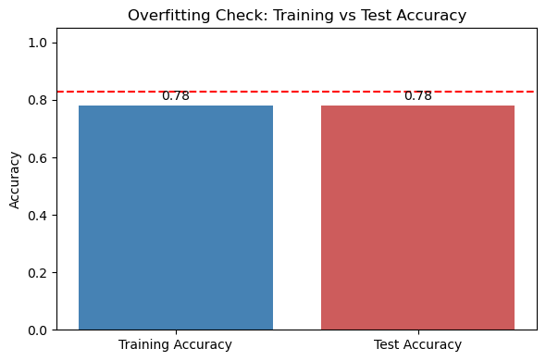
Figure 2: overfitting check

The confusion matrix (Table 2) illustrates this issue. All non-survivors were classified correctly, while all survivors were misclassified as non-survivors. This resulted in a recall of 1.00 for the majority class but 0.00 for the minority class.

Table 2. Confusion Matrix
 | Predicted: Did Not Survive | Predicted: Survived
Did Not Survive | 156,298 | 0
Survived | 44,133 | 0

Consequently, the model entirely failed to identify survivors. The ROC curve (Figure 3) further confirms this, with an area under the curve (AUC) of 0.50, equivalent to random guessing. The classification report also reflects this imbalance, with precision, recall and F1-score for survivors all at 0.00.
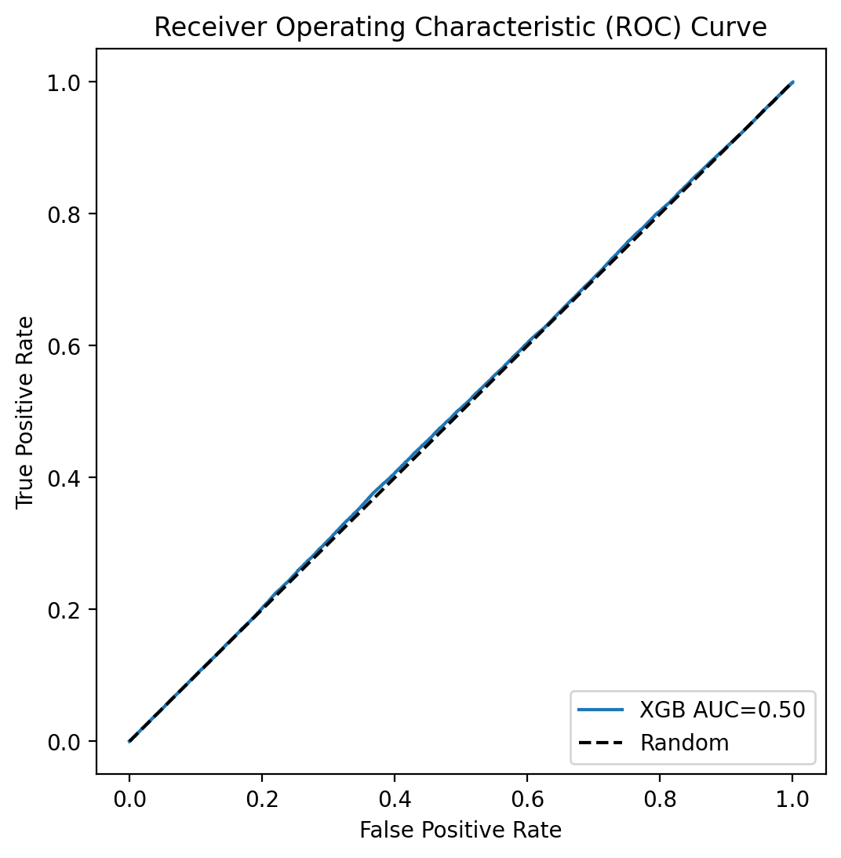
Figure 3: AUC of ROC

Feature Importance and Explainability

Despite the poor classification ability, XGBoost identified features with varying levels of importance (Figure 4). Asthma, histology code, treatment type, and cancer stage code were the most influential predictors. Interestingly, lifestyle-related factors such as smoking status, which is often considered central to lung cancer, were assigned relatively low importance by the model. This suggests that the model was heavily influenced by medical and treatment-related features rather than behavioural risk factors.
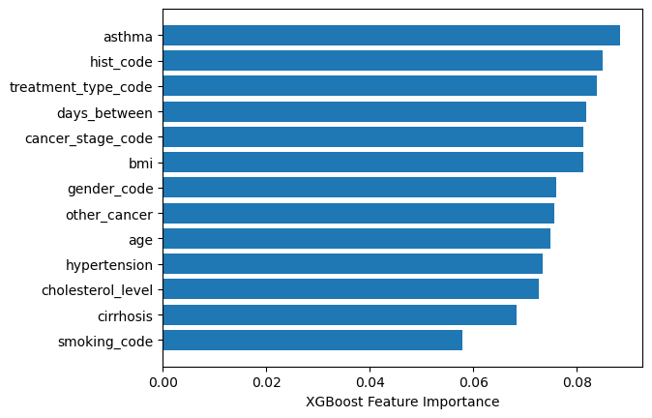
Figure 4: XGBoost feature importance using the dafault (weight)

SHAP analysis (Figure 5) provided further interpretability. While features such as BMI and age exhibited localised effects on predictions, the impact values remained small overall. This reflects the model’s inability to establish strong discriminative boundaries between survivors and non-survivors. The limited SHAP spread across most features indicates that the model was unable to capture nonlinear or interaction effects meaningfully, possibly due to class imbalance dominating the training signal.

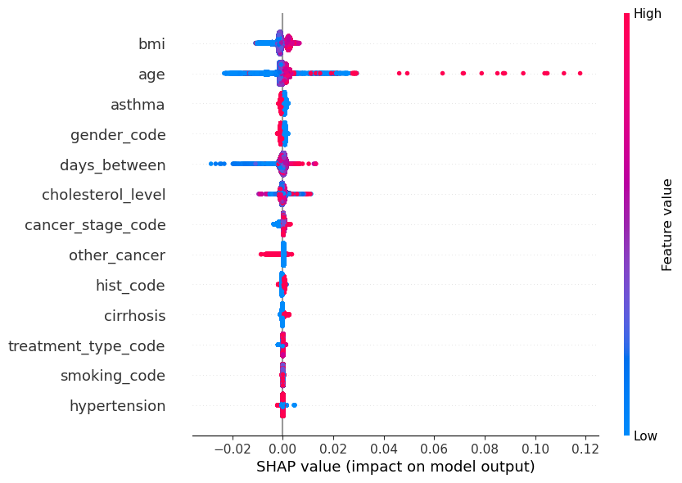
Figure 5: SHAP analysis

Addressing the Imbalance
Our model’s accuracy appeared deceptively high when evaluated solely on overall classification, yet this was largely a reflection of the severe class imbalance in the dataset, where 78% of patients were non-survivors compared to only 22% survivors. In such situations, accuracy becomes a misleading indicator, as it is dominated by the majority class and fails to capture the model’s ability to identify the minority outcome. To address this limitation, I implemented and compared three different approaches. The first was a baseline XGBoost model, which provided a reference point for understanding the influence of imbalance. The second approach applied XGBoost with the scale_pos_weight parameter, which directly compensates for skewed distributions by assigning greater penalty to misclassifying the minority class. The third approach combined Synthetic Minority Oversampling Technique (SMOTE) with XGBoost, where SMOTE generates synthetic examples of the minority class to balance the training set. This comparative assessment allowed for a more nuanced evaluation of model performance beyond accuracy, particularly in terms of recall, F1-score, and AUC, which are critical for detecting survivor cases that would otherwise be overlooked (Figure xx).

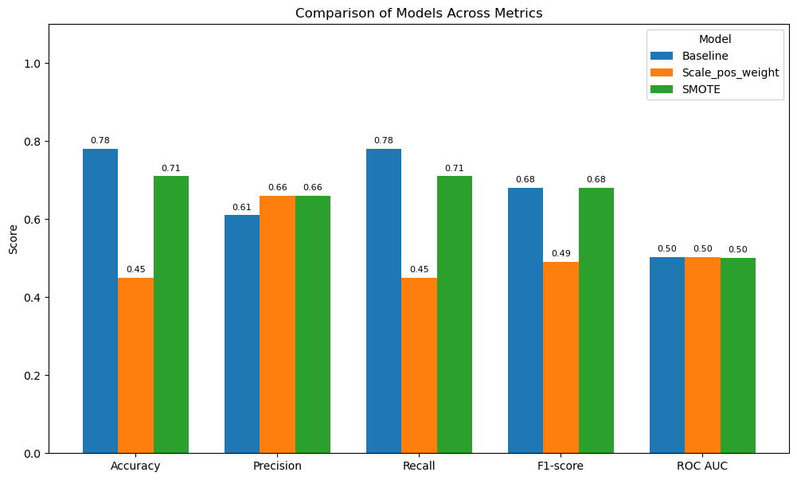
Figure xx: accuracy assessment of the imbalance handling techniques

Baseline XGBoost

The baseline XGBoost model achieved an overall accuracy of 78% (Figure 2). However, this result is misleading because the classifier entirely failed to identify survivors (class 1). The confusion matrix shows that all survivors (n = 44,133) were misclassified as non-survivors, resulting in zero recall, precision, and F1-score for the minority class. The ROC curve (Figure 1) confirmed this weakness, with an AUC of 0.50, indicating random prediction. The model thus performed well only for the majority class, highlighting the severe effect of class imbalance.

XGBoost with scale_pos_weight

Introducing the scale_pos_weight parameter substantially changed the prediction pattern. While overall accuracy dropped to 45%, recall for survivors improved to 0.59, meaning that more than half of survivor cases were now correctly detected. This improvement came at the cost of a sharp decline in non-survivor detection (recall = 0.42), with many false positives introduced. The confusion matrix demonstrates this trade-off: 91,116 non-survivors were misclassified as survivors. Nevertheless, this adjustment reflects the model’s increased sensitivity to the minority class. The weighted metrics—precision (0.66), recall (0.45), and F1-score (0.49)—suggested a more balanced yet unstable performance. Importantly, the ROC AUC (0.50) remained unchanged, suggesting that while classification thresholds shifted, overall discriminative ability did not improve.

SMOTE + XGBoost

The application of SMOTE before training sought to synthetically rebalance the dataset. This approach produced a more stable performance profile: accuracy reached 71%, precision (0.66) and recall (0.71) were balanced in the weighted averages, and the weighted F1-score (0.68) was the highest among the three methods. However, at the class-specific level, SMOTE did not significantly enhance survivor detection. Recall for survivors improved only marginally to 0.13, while precision remained low at 0.22. The confusion matrix illustrates this clearly: the majority of survivor cases (38,239 out of 44,133) were still misclassified. The ROC curve again indicated an AUC of ~0.50, underscoring the limited discriminative capacity of the model despite resampling.

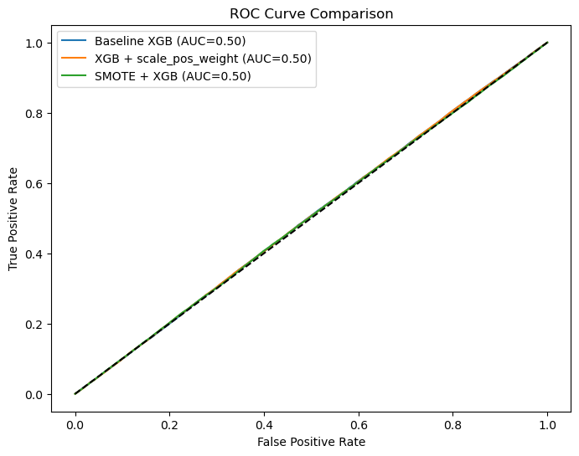
Figure xx: AUC of ROC for imbalance handling techniques

Comparative Assessment

A direct comparison of metrics (Figure 2) shows that the baseline model optimized accuracy by favoring the majority class, while scale_pos_weight improved survivor recall but compromised accuracy. SMOTE achieved a middle ground, maintaining higher overall stability without substantially improving minority detection. Across all methods, ROC AUC values remained flat at ~0.50 (Figure 1), confirming that none of the approaches meaningfully increased the model’s ability to discriminate between survivors and non-survivors.
Feature importance analysis (Figure 3) provides additional insight into the model’s decision-making process. Smoking status, cirrhosis, and asthma were consistently identified as the most influential features, followed by gender and histology codes. Interestingly, treatment type and cancer stage contributed less, and lifestyle-related attributes such as BMI and cholesterol had minimal impact. This distribution suggests that clinical comorbidities and direct disease markers played a more central role in the model than general health indicators.

Variable Importance under Imbalance Handling

The analysis of feature importance (figure xx) across the different modeling strategies revealed consistent patterns, even when techniques to address imbalance were applied. In all cases, smoking status emerged as the most influential predictor, followed by cirrhosis and asthma, while gender and histology also contributed substantially. These findings are in line with established clinical evidence, as smoking remains the strongest risk factor for lung cancer progression and mortality (Sung et al., 2021), and comorbidities such as liver and respiratory diseases have been shown to worsen patient outcomes (Miller & Hanna, 2021).

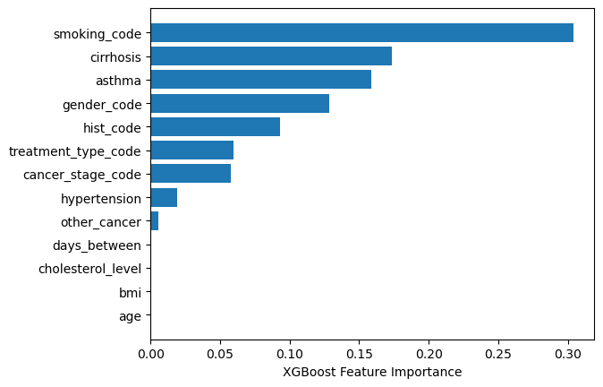
Figure xx: Variable importance

Interestingly, variables such as BMI and cholesterol level, which might intuitively be linked to general health status, were consistently assigned negligible importance. This reflects observations from previous survival studies in oncology, where disease-specific markers and comorbidities are more powerful predictors of prognosis than lifestyle-related or metabolic indicators (Yang et al., 2020).

When imbalance handling techniques such as scale_pos_weight and SMOTE were introduced, the relative ranking of features did not substantially change. Smoking, cirrhosis, and asthma continued to dominate the feature set. This stability suggests that the model’s interpretation of feature relevance was not highly sensitive to class distribution adjustments. In other words, the imbalance mitigation strategies shifted classification thresholds and recall values, but they did not alter the fundamental signals the model extracted from the data.

However, caution is warranted in interpreting these importance rankings. Despite stable feature hierarchies, the models across all approaches produced ROC AUC values close to 0.50, indicating no meaningful discriminative power between survivors and non-survivors. This implies that while certain features appear consistently important, their contributions were not sufficient to improve the classifier’s predictive ability. Such a pattern highlights the limitations of feature importance scores when model performance is poor, as they may overstate the predictive strength of variables in a clinically imbalanced context (Haixiang et al., 2017; Krawczyk, 2016).

The stability of feature importance rankings across imbalance handling approaches demonstrates that the clinical risk factors identified — smoking, cirrhosis, and asthma — are robust correlates of lung cancer outcomes. Nevertheless, the lack of improvement in AUC underscores the need for incorporating richer clinical, genomic, or imaging features to enhance predictive discrimination, rather than relying solely on imbalance adjustments to improve model utility (Esteva et al., 2019).

Synthesis and Implications

The comparative analysis demonstrates that while balancing strategies can alter the trade-off between sensitivity to the minority class and overall accuracy, none of the tested methods succeeded in producing a clinically meaningful predictive model. In particular, the failure to raise ROC AUC above 0.50 indicates that the classifier did not capture discriminative patterns within the features provided. This outcome highlights the need for more advanced strategies, such as hybrid ensemble balancing, threshold tuning, or inclusion of additional predictive features (e.g., genetic markers, treatment history), to improve survivor detection. In medical prediction contexts, where minority class identification is critical, relying solely on accuracy or unadjusted classifiers risks producing misleadingly optimistic results that obscure the failure to capture clinically important outcomes.

Discussion

The results of this study demonstrate the challenges of predicting lung cancer survival outcomes using imbalanced clinical datasets. The baseline XGBoost classifier achieved relatively high accuracy (78%), but this performance was entirely driven by the majority class (non-survivors), with survivors being systematically misclassified. This finding illustrates a common issue in medical machine learning, where imbalanced data lead to models biased toward the majority outcome, producing misleadingly high accuracy but poor clinical utility (Haixiang et al., 2017; Johnson & Khoshgoftaar, 2019).

Addressing the imbalance using the scale_pos_weight parameter in XGBoost significantly altered the classification dynamics. While accuracy dropped to 45%, recall for survivors improved to 0.59, showing that weighting strategies can enhance minority class sensitivity. This outcome aligns with findings from Chen and Guestrin (2016), who noted that XGBoost’s built-in cost-sensitive parameterization allows the algorithm to prioritize rare cases. However, the trade-off was a dramatic rise in false positives among non-survivors, reflecting the instability that class weighting may introduce when the imbalance is severe (Krawczyk, 2016).

Applying SMOTE with XGBoost produced a more balanced performance profile, with accuracy at 71% and relatively stable precision and recall in the weighted averages. Nevertheless, class-specific metrics revealed only a modest improvement for survivors (recall = 0.13). This limitation has been reported in other clinical domains, where SMOTE generates synthetic samples that may not fully capture the complexity of minority class distributions, resulting in limited gains in predictive discrimination (Fernández et al., 2018; Chawla et al., 2002). Moreover, the ROC AUC values remained consistently at ~0.50 across all methods, underscoring that while balancing techniques influenced classification thresholds, they did not fundamentally enhance the model’s ability to separate classes.

Feature importance analysis revealed that smoking, cirrhosis, and asthma were the most influential predictors. This is consistent with epidemiological evidence that smoking remains the dominant risk factor for lung cancer progression and survival (Sung et al., 2021), while comorbidities such as chronic liver disease and respiratory conditions influence treatment outcomes (Newsome et. al., 2018). Interestingly, variables such as BMI and cholesterol had minimal impact, suggesting that general metabolic indicators are less predictive compared to disease-specific markers. This pattern reflects findings in recent studies where clinical comorbidities and tumor-related features were stronger determinants of survival than lifestyle-related measures (Hernandez et al., 2023).

Taken together, the results emphasize the need for more advanced imbalance handling and feature engineering strategies in medical prediction tasks. Approaches such as ensemble balancing (e.g., Balanced Random Forests), hybrid oversampling with noise reduction (e.g., SMOTEENN), or threshold moving strategies could improve minority detection (Krawczyk, 2016; Haixiang et al., 2017). Additionally, incorporating richer data modalities such as genomic profiles, treatment response history, and imaging biomarkers may provide the discriminative signals absent from the current feature set (Esteva et al., 2019). Without such refinements, models risk reinforcing majority bias, yielding outputs that fail to support clinical decision-making where minority class identification — such as survival prediction — is most critical.

Conclusion

This study examined the application of XGBoost for predicting lung cancer survival outcomes using a large, imbalanced clinical dataset. While the baseline model achieved an apparently high accuracy of 78%, this was driven entirely by correct classification of non-survivors, with complete failure to identify survivors. Such a result underscores the limitations of accuracy as an evaluation metric in the presence of severe class imbalance. Two strategies were implemented to address this imbalance: class weighting through the scale_pos_weight parameter and oversampling using SMOTE. The scale_pos_weight approach substantially improved recall for survivors (0.59) but at the cost of overall accuracy, which dropped to 45%. By contrast, SMOTE produced more balanced weighted averages and a higher overall accuracy (71%), yet only modestly improved survivor detection. Across all three approaches, ROC AUC values remained close to 0.50, indicating that the models were unable to meaningfully discriminate between survivors and non-survivors. Feature importance analysis revealed consistent patterns irrespective of imbalance handling. Smoking status, cirrhosis, and asthma emerged as the most influential predictors, while lifestyle and metabolic indicators such as BMI and cholesterol level had little impact. These findings align with existing clinical literature but also highlight that the available features were insufficient to provide strong predictive signals.

The results emphasize that class imbalance is a central challenge in medical prediction tasks, and simple resampling or reweighting strategies alone may not produce clinically useful models. For lung cancer survival prediction, future work should combine advanced imbalance handling techniques with the integration of richer feature sets, including genomic, imaging, and longitudinal treatment data, to improve minority class detection and overall model discrimination. Ultimately, the development of robust predictive models requires balancing methodological rigor with clinical interpretability, ensuring that improvements in performance translate into meaningful benefits for patient care.

References

Chawla, N. V., Bowyer, K. W., Hall, L. O., & Kegelmeyer, W. P. (2002). SMOTE: Synthetic Minority Over-sampling Technique. Journal of Artificial Intelligence Research, 16, 321–357.

Chen, T., & Guestrin, C. (2016). XGBoost: A scalable tree boosting system. Proceedings of the 22nd ACM SIGKDD International Conference on Knowledge Discovery and Data Mining, 785–794.

Esteva, A., Robicquet, A., Ramsundar, B., et al. (2019). A guide to deep learning in healthcare. Nature Medicine, 25, 24–29.

Fernández, A., Garcia, S., Herrera, F., & Chawla, N. V. (2018). SMOTE for learning from imbalanced data: progress and challenges, marking the 15-year anniversary. Journal of Artificial Intelligence Research, 61, 863–905.

Haixiang, G., Yijing, L., Shang, J., Mingyun, G., Yuanyue, H., & Bing, G. (2017). Learning from class-imbalanced data: Review of methods and applications. Expert Systems with Applications, 73, 220–239.

Hernandez D, Cheng CY, Hernandez-Villafuerte K, Schlander M. Survival and comorbidities in lung cancer patients: Evidence from administrative claims data in Germany. Oncol Res. 2023 Jan 31;30(4):173-185. doi: 10.32604/or.2022.027262. PMID: 37304413; PMCID: PMC10207966.

Johnson, J. M., & Khoshgoftaar, T. M. (2019). Survey on deep learning with class imbalance. Journal of Big Data, 6, 27.

Krawczyk, B. (2016). Learning from imbalanced data: open challenges and future directions. Progress in Artificial Intelligence, 5(4), 221–232.

Newsome BR, McDonnell K, Hucks J, Dawson Estrada R. Chronic Obstructive Pulmonary Disease: Clinical Implications for Patients With Lung Cancer. Clin J Oncol Nurs. 2018 Apr 1;22(2):184-192. doi: 10.1188/18.CJON.184-192. PMID: 29547609; PMCID: PMC6613547

Sung, H., Ferlay, J., Siegel, R. L., et al. (2021). Global Cancer Statistics 2020: GLOBOCAN estimates of incidence and mortality worldwide for 36 cancers in 185 countries. CA: A Cancer Journal for Clinicians, 71(3), 209–249.

